The Magnificent Story

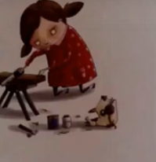
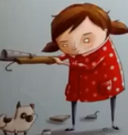

The girl and her assistant started making something magnificent.
This a random girl she is trying to make something magnificent.

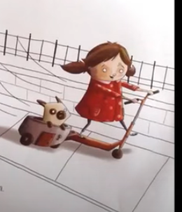
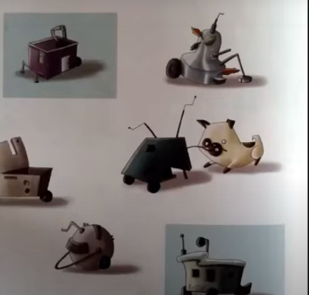

Although there was nothing magnificent to them ,happiness was the most magnificent thing they could have.
They made a number of items continuously ,trying to create something magnificent as the idea in her brain but she could not.

